Muhammad Roychan Meliaz
FSDO001ONL021

OCBC – Hacktiv8 Bootcamp
Final Project - Angular
Angular PaymentDetail App

Angular Payment App heroku link: https://roy-021-angular-payment.herokuapp.com/
C# .NET API endpoint heroku link: https://fp-payment-roy.herokuapp.com/api/PaymentDetail

Homepage
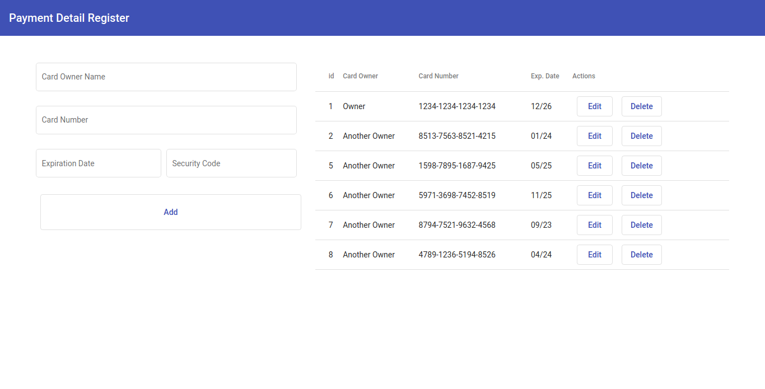

Form Validation
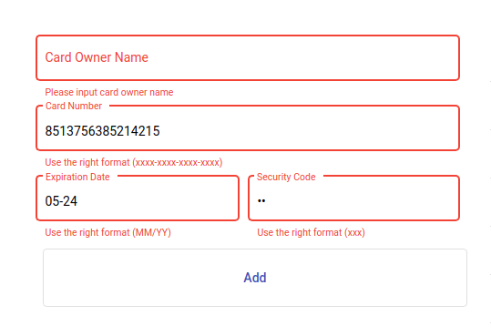

Loading Request
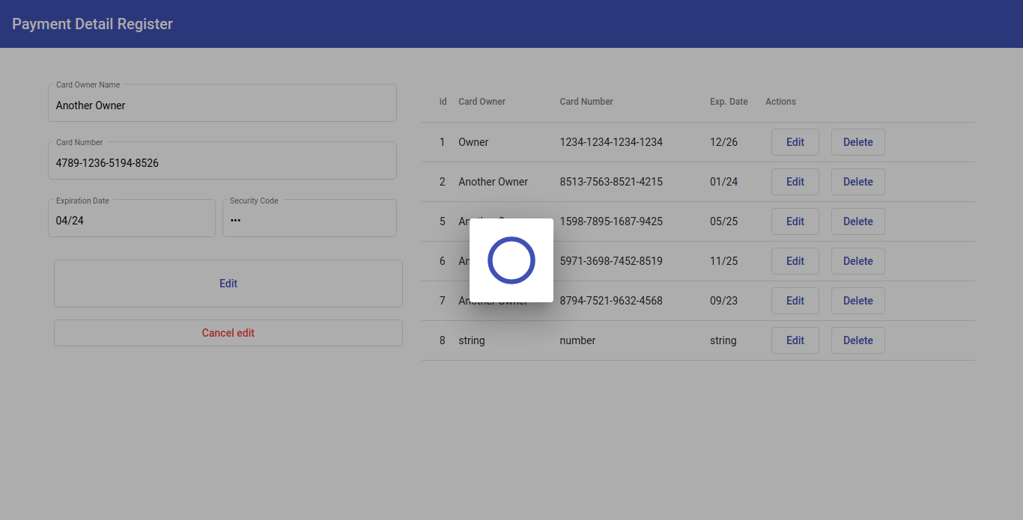

Request Success
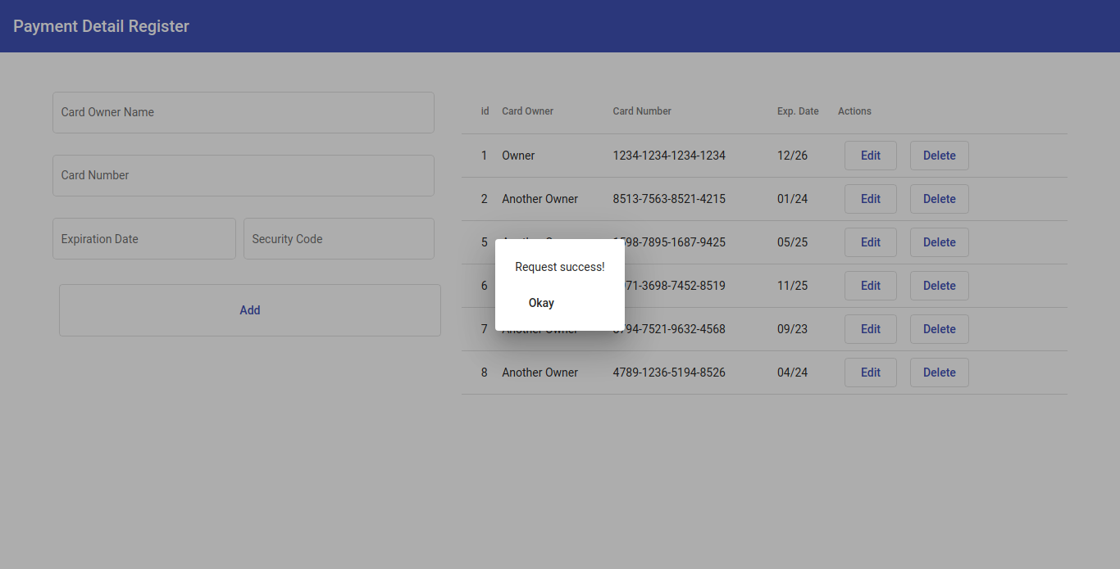

Request Error
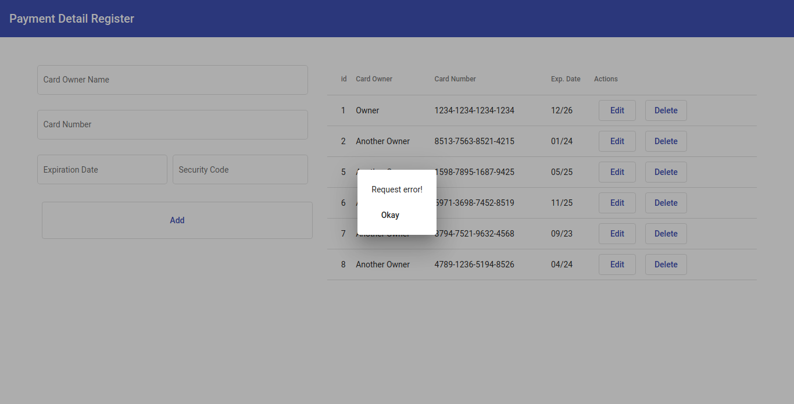

Delete Confirmation
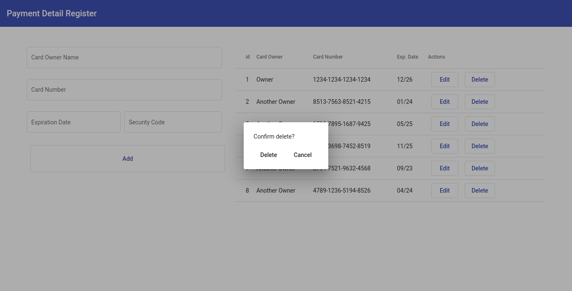

Edit Mode
